 

**FACE RECOGNITION BASED ATTENDANCE MANAGEMENT SYSTEM**

**A MINI PROJECT REPORT**

*Submitted by*

GOWTHAM S - 913320104017

VIGNESH M - 913320104304

SHARAN T - 913320104047

*In partial fulfillment for the award of degree*

*of*

BACHELOR OF ENGINEERING

IN

**COMPUTER SCIENCE ENGINEERING**

VAIGAI COLLEGE OF ENGINEERING ,MELUR

ANNA UNIVERSITY::CHENNAI 600 025

**BONAFIDE CERTIFICATE**

Certified that this project report **“FACE RECOGNITION BASED ATTENDANCE MANAGENENT SYSTEM”** is the bonafide work of **GOWTHAM.S (913320104017), VIGNESH.M (913320104304), SHARAN.T (913320104047)** who carried out the project work under my supervision.

|  |  |
| --- | --- |
| **SIGNATURE** | **SIGNATURE** |
| Mrs.P.DIVYA BHARATHI M.E., | Mrs.M M.E.,Ph.D., |
| **HEAD OF THE DEPARTMENT** | **SUPERVISOR** |
| Assistant Professor | Assistant Professor |
| Computer Science and Engineering | Computer Science and Engineering |
| Vaigai College of Engineering, Melur | Vaigai College of Engineering, Melur |
| Madurai-625 122 | Madurai-625 122 |

Project viva voice held on _____________

**INTERNAL EXAMINAR EXTERNAL EXAMINAR**

**ABSTRACT**

In this digital era, face recognition system plays a vital role in almost every sector. Face recognition is one of the mostly used biometrics. It can used for security, authentication, identification, and has got many more advantages. Despite of having low accuracy when compared to iris recognition and fingerprint recognition, it is being widely used due to its contactless and non-invasive process. Furthermore, face recognition system can also be used for attendance marking in schools, colleges, offices, etc. This system aims to build a class attendance system which uses the concept of face recognition as existing manual attendance system is time consuming and cumbersome to maintain. And there may be chances of proxy attendance. Thus, the need for this system increases. This system consists of four phases- database creation, face detection, face recognition, attendance updation. Database is created by the images of the students in class. Face detection and recognition is performed using Haar-Cascade classifier and Local Binary Pattern Histogram algorithm respectively. Faces are detected and recognized from live streaming video of the classroom. Attendance will be mailed to the respective faculty at the end of the session.

**ACKNOWLEDGEMENT**

In the presentation of this report we recall with sincere gratitude of each of those who have been a source of immense help and inspiration during the progress of report.

In the regards we would like to thank our respected chairman sir **Dr R THIRUCHENDURAN,** for providing us an excellent environment to carry out our course successfully.

We would like to Express our sincere thanks to our Principal **Dr.SIVARANJANI** forwarding us to do our project and offering adequate duration in completing our project.

We consider ourselves very fortunate in being able to do this project with constant support from **Mrs.DIVYABHARATHI P M.E.,** Head of the Department of  **COMPUTER SCIENCE AND ENGINEERING,** who molded us both technically and morally for achieving greater success in life.

We express our heartfelt gratitude to my guide **Mrs.KANIMOZHI M M.E.,(Ph.D)**Assistantprofessor,Department of **Computer Science and Engineering** for her priceless guidance and motivation which helped me to bring this project to perfect shape who encouraged us in each and every step of this project to complete it successfully.

We thank all the  **STAFF MEMBERS**  of our department for their valuable support and assistance at various stages of our project development

**TABLE OF CONTENTS**

|  |  |  |
| --- | --- | --- |
| **S.No** | **TITLE** | **PAGE NO** |
|  | ABSTRACT | 5 |
| 1 | INRODUCTION | 8 |
| 1.1 | OVER VIEW OF THE PROJECT | 8 |
| 1.2 | PROBLEM DEFINITION | 8 |
| 1.3 | PROJECT DESCRIPTION | 8 |
| 1.4  2  3  3.1  3.1.1  3.2  3.2.1  4  4.1  4.2  4.2.1  4.2.2  4.2.3  4.2.4    5  6  7  8  9 | PURPOSE OF PROJECT  LITERATURE SURVEY  SYSTEM ANALYSIS  EXISTING SYSTEM  DRAWBACKS OF EXISTING SYSTEM  PROPOSED SYSTEM  ADVANTAGES OF PROPOSED SYSTEM  SYSTEM DESIGN  INTRODUCTION TO USE CASE MODEL  INTRODUCTION TO USE CASE DIAGRAM  DESCRIPTION OF SYMBOLS  USE CASE DIAGRAM  ARCHITECTURE  SEQUENCE DIAGRAM  SYSTEM ARCHITECTURE  RESULTS AND DISCUSSIONS  APPENDIX  CONCLUSION AND FUTURE ENHANCEMENT  REFERENCES | 8  9  10  10  10  10  10  11  11  11  11  12  12  13  13  16  21  25  26 |

**INTRODUCTION**

**1.1 OVER VIEW OF THE PROJECT**

The face recognition based attendance system is an smart attendance management system. It is developed for daily student attendance in colleges and schools. This project attempts to record attendance through face detection.

This system uses facial recognition technology to record the attendance through a high resolution digital camera or webcam that detects and recognizes faces and compare the recognize faces and compare the recognize faces with students/known faces images stored in faces database. It saves the time and effort of the manual system.

**1.2PROBLEM DEFINITION**

The College/school Management has to take attendance for many number of students and maintenance was difficult. Though it has used an information system, it was totally manual. Hence there is a need to upgrade the system with a computer based information system.

**1.3 PROJECT DESCRIPTION**

The face recognition based attendance management system allows authorized members to access the record of academically registered students. It can be used in various educational institutes across the globe and simplifies working of institutes.

**1.4 PURPOSE OF THE PROJECT**

The purpose of this system is to build a attendance system which is based on face recognition techniques. Here face of an individual will be considered for marking attendance. Nowadays, face recognition is gaining more popularity and has been widely used. In this paper, we proposed a system which detects the faces of students from live streaming video of classroom and attendance will be marked if the detected face is found in the database. This new system will consume less time than compared to traditional methods.

**LITERATURE SURVEY**

Authors in proposed a model of an automated attendance system. The model focuses on how face recognition incorporated with Radio Frequency Identification (RFID) detect the authorized students and counts as they get in and get out form the classroom. The system keeps the authentic record of every registered student. The system also keeps the data of every student registered for a particular course in the attendance log and provides necessary information according to the need. In this paper, Authors have designed and implemented an attendance system which uses iris biometrics. Initially, the attendees were asked to register their details along with their unique iris template. At the time of attendance, the system automatically took class attendance by capturing the eye image of each attendee, recognizing their iris, and searching for a match in the created database. The prototype was web based. In authors proposed an attendance system based on facial recognition. The algorithms like Viola-Jones and Histogram of Oriented Gradients (HOG) features along with Support Vector Machine (SVM) classifier were used to implement the system. Various real time scenarios such as scaling, illumination, occlusions and pose was considered by the authors. Quantitative analysis was done on the basis of Peak Signal to Noise Ratio (PSNR) values and was implemented in MATLAB GUI. Authors in researches to get best facial recognition algorithm (Eigenface and Fisherface) provided by the Open CV 2.4.8 by comparing the Receiver Operating Characteristics (ROC) curve and then implemented it in the attendance system. Based on the experiments carried out in this paper, the ROC curve proved that, Eigenface achieves better result than Fisherface. System implemented using Eigenface algorithm achieved an accuracy rate of 70% to 90%. Authors proposed a method for student attendance system in classroom using face recognition technique by combining Discrete Wavelet Transforms (DWT) and Discrete Cosine Transform (DCT). These algorithms were used to extract the features of student’s face followed by applying Radial Basis Function (RBF) for classifying the facial objects. This system achieved an accuracy rate of 82%.

**3.SYSTEM ANALYSIS**

Systems analysis is the study of sets of interacting entities, including computer systems analysis. This field is closely related to requirement analysis or operations research

**3.1 EXISTING SYSTEM**

At present all the student information are recorded manually. All the details of the are maintained in a single record. So searching and updating the details is a tedious process

**3.1.1 DRAWBACKS OF EXISTING SYSTEM**

* It is hard to maintain a student information manually.
* Manipulation of student details is difficult for teachers.

**3.2 PROPOSED SYSTEM:**

We introduce our project to maintain a face recognition based attendance management system easily by computer a system and reduce the paper work.

**3.2.1 ADVANTAGES OF PROPOSED SYSTEM:**

* Easy to use, manage and retrieve database.
* User friendly environment.
* With the database any data can be added, modified, deleted very quickly.

**4.SYSTEM DESIGN**

**4.1 INTRODUCTION TO USE CASE MODEL:**

The Use-case model is defined as a model which is used to show how users interact with the system in order to solve a problem. As such, the use case model defines the user's objective, the interactions between the system and the user, and the system's behavior required to meet these objectives.

**4.2 INTRODUCTION TO USE CASE DIAGRAM:**

A use case diagram is used to represent the dynamic behavior of a system. It encapsulates the system's functionality by incorporating use cases, actors, and their relationships. It models the tasks, services, and functions required by a system/subsystem of an application.

**4.2.1 DESCRIPTION OF SYMBOLS**

Use cases:

Horizontally shaped ovals that represent the different uses that a user might have.

Actors: 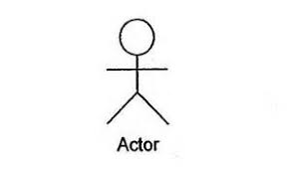

Stick figures that represent the people actually employing the use cases.

Associations : 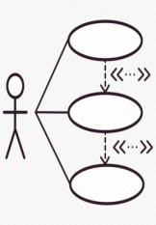

A line between actors and use case

**4.2.2 USE CASE DIAGRAM**

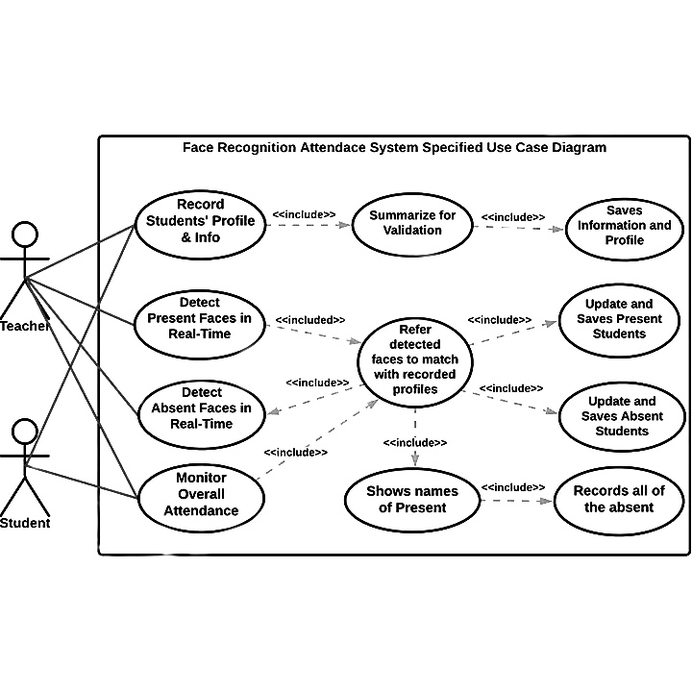

**4.2.3 ARCHITECTURE**

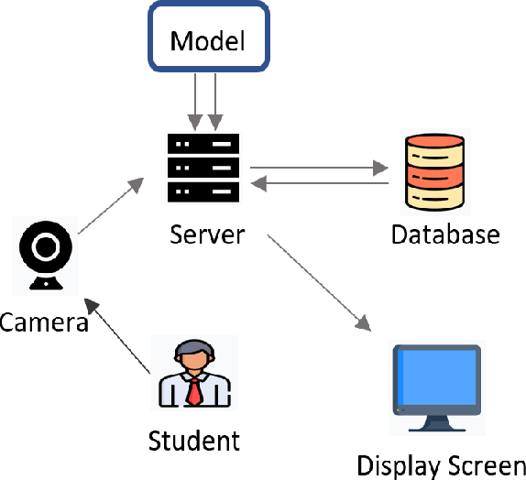

**4.2.4 SEQUENCE DIAGRAM**

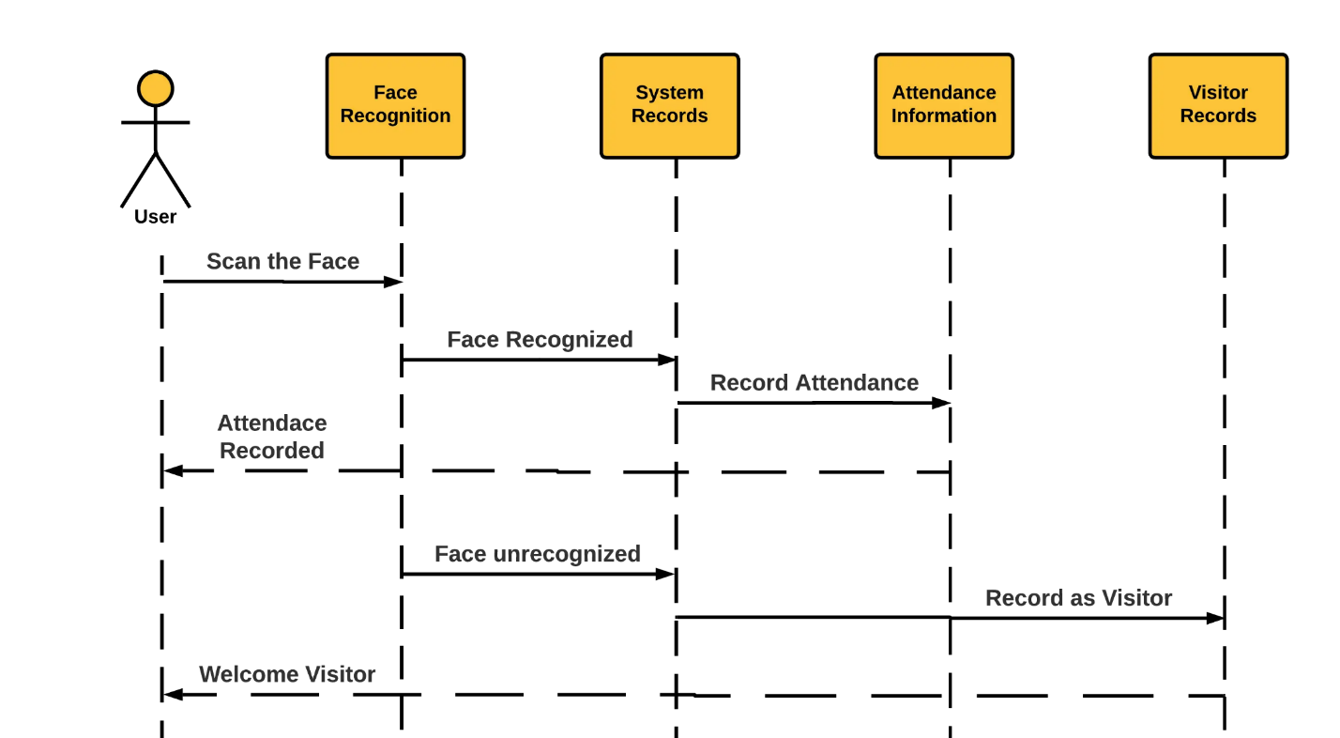

**5.SYSTEM ARCHITECTURE**

The system architecture of the proposed system is given below,

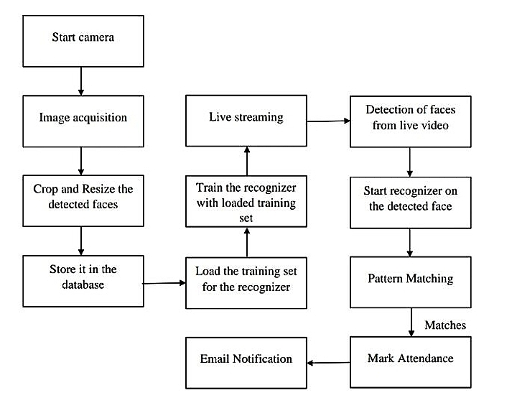

Typically this process can be divided into four stages,

1. Dataset creation
2. Face Detection
3. Face Recognition
4. Attendance Updation

**1.DATASET CREATION**

Images of students are captured using a web cam. Multiple images of single student will be acquired with varied gestures and angles. These images undergo pre-processing. The images are cropped to obtain the Region of Interest (ROI) which will be further used in recognition process. Next step is to resize the cropped images to particular pixel position. Then these images will be converted from RGB to gray scale images. And then these images will be saved as the names of respective student in a folder.

**2.FACE DETECTION**

Face detection here is performed using Haar-Cascade Classifier with OpenCV. Haar Cascade algorithm needs to be trained to detect human faces before it can be used for face detection. This is called feature extraction. The haar cascade training data used is an xml filehaarcascade_frontalface_default. The haar features will be used for feature extraction.

**3.FACE RECOGNITION**

Face recognition process can be divided into three stepsprepare training data, train face recognizer, prediction. Here training data will be the images present in the dataset. They will be assigned with a integer label of the student it belongs to. These images are then used for face recognition. Face recognizer used in this system is Local Binary Pattern Histogram. Initially, the list of local binary patterns (LBP) of entire face is obtained. These LBPs are converted into decimal number and then histograms of all those decimal values are made. At the end, one histogram will be formed for each images in the training data. Later, during recognition process histogram of the face to be recognized is calculated and then compared with the already computed histograms and returns the best matched label associated with the student.

**4.ATTENDANCE UPDATION**

After face recognition process, the recognized faces will be marked as present in the excel sheet and the rest will be marked as absent and the list of absentees will be mailed to the respective faculties. Faculties will be updated with monthly attendance sheet at the end of every month.

**6.RESULTS AND DISCUSSIONS**

The users can interact with the system using a GUI. Here users will be mainly provided with three different options such as, student registration, faculty registration, and mark attendance. The students are supposed to enter all the required details in the student registration form. After clicking on register button, the web cam starts automatically and window. pops up and starts detecting the faces in the frame. Then it automatically starts clicking photos until 60 samples are collected or CRTL+Q is pressed. These images then will be pre-processed and stored in training images folder. The faculties are supposed to register with the respective course codes along with their email-id in the faculty registration form provided. This is important because the list of absentees will be ultimately mailed to the respective faculties.

In every session, respective faculty must enter their course code. Then after submitting the course code, the camera will start automatically. The face recognition window where two registered students are recognized and if in case they were not registered it would have shown ‘unknown’. By pressing CTRL+Q, the window will be closed and attendance will be updated in the excel sheet and names of absentees will be mailed to the respective faculty.

**ADDING INFORMATION ABOUT CLIENTS:**

This database stores the data about the clients/students who enrolled individuals' facial information, names.

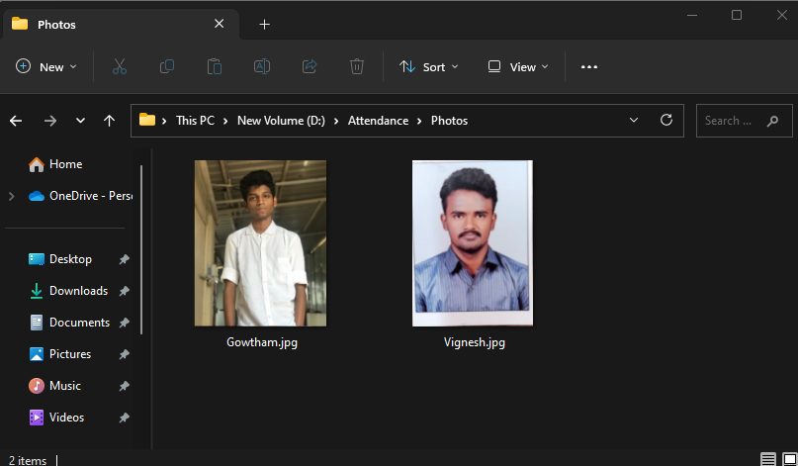

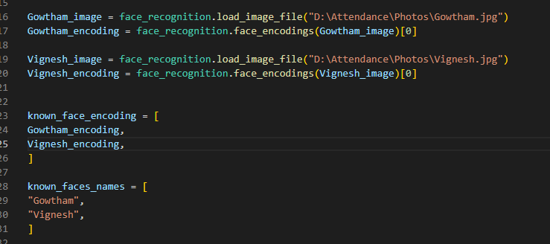

**LOGIN PAGE:**

The administrator login is used to configure the attendance system according to the specific requirements of the organization. This may include setting up working hours, defining attendance rules, managing user roles and permissions, and customizing various system settings.



**FACE DETECTION POPUP:**

The face recognition process begins with face detection, where an algorithm locates and extracts facial features from an image or video frame. This step involves identifying regions of an image that potentially contain faces.

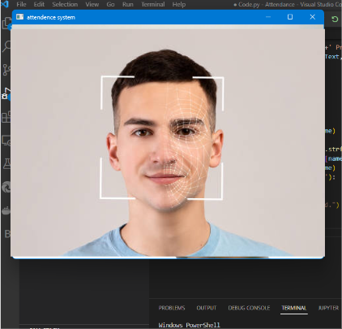

**FACE ANALIZATION:**

It works by identifying and measuring facial features in an image. Facial recognition can identify human faces in images or videos, determine if the face in two images belongs to the same person, or search for a face among a large collection of existing images.

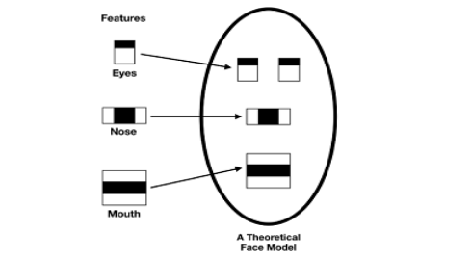

**ATTENDANCE UPDATION:**

After face recognition process, the recognized faces will be marked as present in the excel sheet and the rest will be marked as absent and the list of absentees will be mailed to the respective faculties.

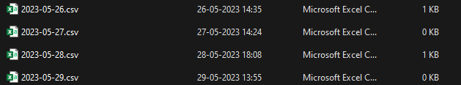

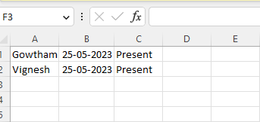

**APPENDIX:**

This main function in tis code acts as a starting point and control center for the program's execution, allowing you to define the program's flow and incorporate various functionalities based on your specific needs.

import face_recognition

import cv2

import numpy as np

import csv

import os

from datetime import datetime

def login():

username = input("Enter your username: ")

password = input("Enter your password: ")

if username == "admin" and password == "123":

print("Login successful!")

video_capture = cv2.VideoCapture(0)

Gowtham_image = face_recognition.load_image_file("D:\Attendance\Photos\Gowtham.jpg")

Gowtham_encoding = face_recognition.face_encodings(Gowtham_image)[0]

Vignesh_image = face_recognition.load_image_file("D:\Attendance\Photos\Vignesh.jpg")

Vignesh_encoding = face_recognition.face_encodings(Vignesh_image)[0]

known_face_encoding = [

Gowtham_encoding,

Vignesh_encoding,

]

known_faces_names = [

"Gowtham",

"Vignesh",

]

students = known_faces_names.copy()

face_locations = []

face_encodings = []

face_names = []

s=True

now = datetime.now()

current_date = now.strftime("%Y-%m-%d")

f = open(current_date+'.csv','w+',newline = '')

lnwriter = csv.writer(f)

while True:

_,frame = video_capture.read()

small_frame = cv2.resize(frame,(0,0),fx=0.25,fy=0.25)

rgb_small_frame = small_frame[:,:,::-1]

if s:

face_locations = face_recognition.face_locations(rgb_small_frame)

face_encodings = face_recognition.face_encodings(rgb_small_frame,face_locations)

face_names = []

for face_encoding in face_encodings:

matches = face_recognition.compare_faces(known_face_encoding,face_encoding)

name=""

face_distance = face_recognition.face_distance(known_face_encoding,face_encoding)

best_match_index = np.argmin(face_distance)

if matches[best_match_index]:

name = known_faces_names[best_match_index]

face_names.append(name)

if name in known_faces_names:

font = cv2.FONT_HERSHEY_SIMPLEX

bottomLeftCornerOfText = (10,100)

fontScale = 1.5

fontColor = (255,0,0)

thickness = 3

lineType = 2

cv2.putText(frame,name+' Present',

bottomLeftCornerOfText,

font,

fontScale,

fontColor,

thickness,

lineType)

if name in students:

students.remove(name)

print(students)

current_time = now.strftime("%H-%M-%S")

lnwriter.writerow([name,current_time,'Present'])

cv2.imshow("attendence system",frame)

if cv2.waitKey(1) & 0xFF == ord('q'):

break

else:

print("Invalid username or password.")

video_capture.release()

cv2.destroyAllWindows()

f.close()

**7.CONCLUSION AND FUTURE ENHANCEMENT**

Face Recognition Based Attendance Management System can be used by educational institutions to maintain their student attendance records easily. Achieving this objective is difficult using the manual system as the information is scattered, can be redundant, and collecting relevant information may be very time-consuming. All these problems are solved by this project. This system helps in maintaining the information of pupils of the organization. It can be easily accessed by the manager and kept safe for a long period of time without any changes. In the Future Student can also be able to upload or download notes. We will see the entire system more interactive and also be able to give statistics data. We can run the entire system in any operating system and also we have an android application of this entire system.

This system aims to build an effective class attendance system using face recognition techniques. The proposed system will be able to mark the attendance via face Id. It will detect faces via webcam and then recognize the faces. After recognition, it will mark the attendance of the recognized student and update the attendance record.

**8.REFERENCES :**

[1] ttps://www.researchgate.net/publication/326261079_Face_detection_

system_for_attendance_of_class’_students

[2] Hapani, Smit, et al. "Automated Attendance System Using Image Processing."2018 Fourth International Conference on Computing Communication Control and Automation (ICCUBEA). IEEE, 2018.

[3] Akbar, Md Sajid, et al. "Face Recognition and RFID Verified Attendance System." 2018 International Conference on Computing, Electronics & Communications Engineering (iCCECE). IEEE, 2018.

[4] Okokpujie, Kennedy O., et al. "Design and implementation of a student attendance system using iris biometric recognition." 2017 International Conference on Computational Science and Computational Intelligence (CSCI). IEEE, 2017.

[5] Rathod, Hemantkumar, et al. "Automated attendance system using machine learning approach." 2017 International Conference on Nascent Technologies in Engineering (ICNTE). IEEE, 2017.

[6] Siswanto, Adrian Rhesa Septian, Anto Satriyo Nugroho, and Maulahikmah Galinium. "Implementation of face recognition algorithm for biometrics based time attendance system." 2014 International Conference on ICT For Smart Society (ICISS). IEEE, 2014.

[7] Lukas, Samuel, et al. "Student attendance system in classroom using face recognition technique." 2016 International Conference on Information and Communication Technology Convergence (ICTC). IEEE, 2016.

[8]https://becominghuman.ai/face-detection-using-opencv-with-haarcascade classifiers-941dbb25177.

[9] <https://www.superdatascience.com/blogs/opencv-face-recognition>

[10] Salim, Omar Abdul Rhman, Rashidah Funke Olanrewaju, and Wasiu

Adebayo Balogun. "Class attendance management system using face

recognition." 2018 7th International Conference on Computer and

Communication Engineering (ICCCE). IEEE, 2018.